Standard | Items:
K.CC.01 | 3.0  - Count as far as you can by 1s.  - Count as far as you can by 10s.  2.0  - Count as far as you can by 1s.  - Count as far as you can by 10s.
K.0A.02  Solve addition and subtraction word problems, and add and subtract within 10, e.g., by using objects or drawings to represent the problem. T3 | 3.0  NOTE: Provide a container of bears, drawing paper and crayons for students to use if they choose.  If there are 3 bears at the park and 2 bears at school, how many bears are there in all?  If 8 bears are swimming and 2 go home, how many are left?
2.0
NOTE: Provide a container of bears, drawing paper and crayons for students to use if they choose.
If there are 3 bears at the park and 2 bears at school, how many bears are there in all?
If 8 bears are swimming and 2 go home, how many are left?
K.0A.03  Decompose numbers less than or equal to 10 into pairs in more than one way, e.g., by using objects or drawings, and record each decomposition by a drawing or equation (e.g., 5 = 2 + 3 and 5 = 4 + 1). T3 | 3.0  NOTE: Provides a train of 10 linker cubes.  Break these cubes into two groups. How many are in each group? How many altogether? Write the number sentence or draw your work. (Drawings or equations are acceptable.)  ______ + ______ = 10  Can you show me a different way?  ______ + ______ = 10
2.0
NOTE: Provide a container of bears, drawing paper and crayons for students to use if they choose.
Show me 7 bears. Divide the bears into two groups to show 7 bears in a different way. Record the problem. (Drawings, voice, or equations are acceptable.)

NOTE: Provide a container of bears, drawing paper and crayons for students to use if they choose.
Show me 5 bears. Divide the bears into two groups to show bears in a different way. Record the problem. (Drawings, voice, or equations are acceptable.)

K.OA.04 -  For any number from 1 to 9, find the number that makes 10 when added to the given number, e.g., by using objects or drawings, and record the answer with a drawing or equation. T3 | 3.0  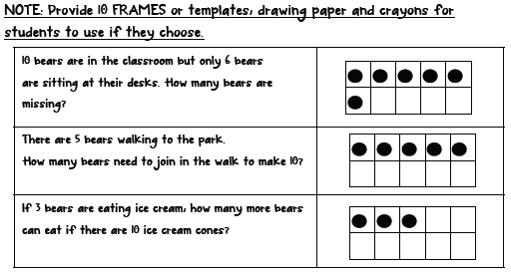  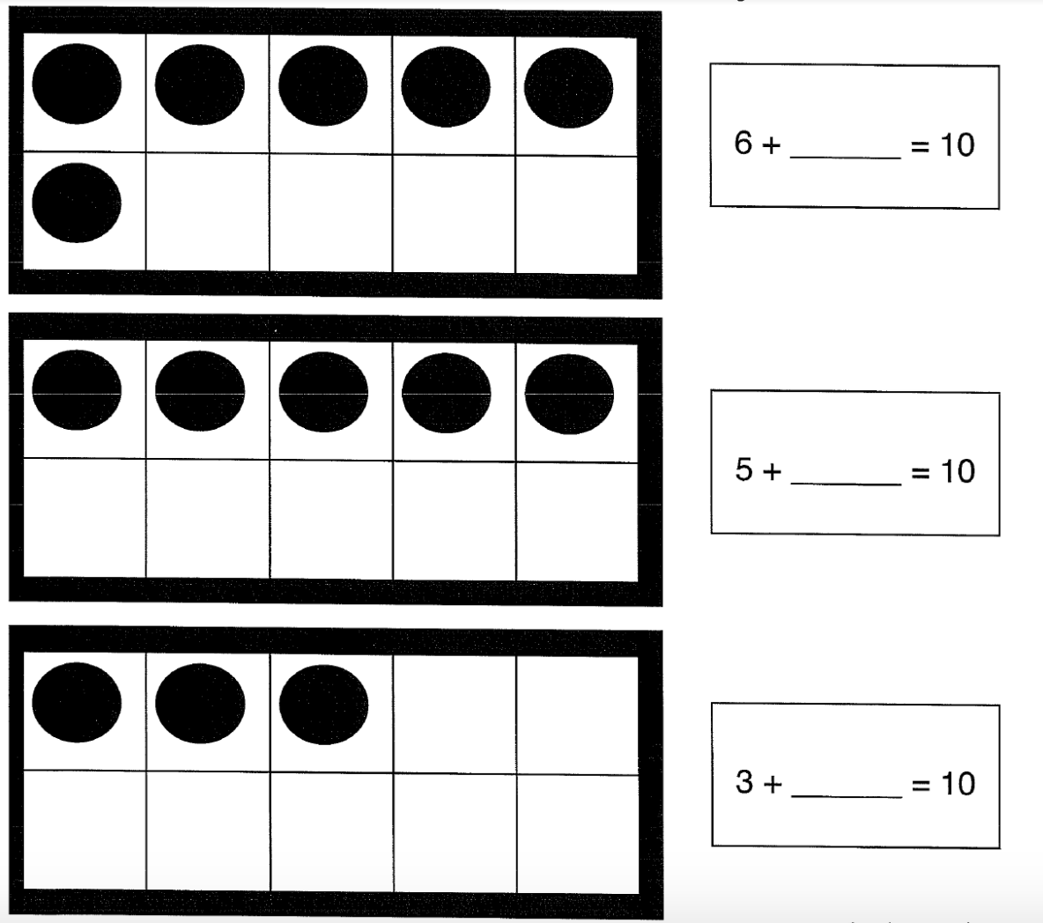
2.0

How many circles are there? How many more do you need to make ten?
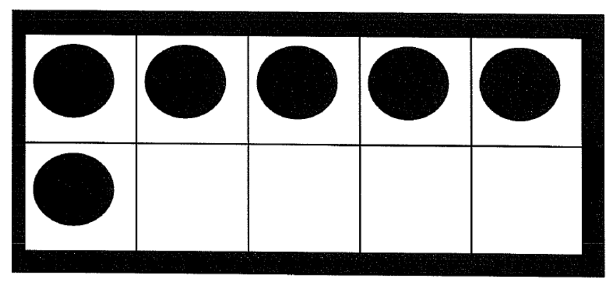

K.NBT.01 -  Compose and decompose numbers from 11 to 19 into ten ones and some further ones, e.g., by using objects or drawings, and record each composition or decomposition by a drawing or equation (e.g., 18 = 10 + 8); understand that these numbers are composed of ten ones and one, two, three, four, five, six, seven, eight, or nine ones several measurable attributes of a single object. T3 | 3.0  Give student a train of ten linker cubes and 9 single cubes.  Tester says: Make 13 with this ten and these ones.  Tester gives student a train of 11 linker cubes and asks:  “Can you break this apart into a group of 10 and ones?”
2.0
Look at this problem. Is it correct?
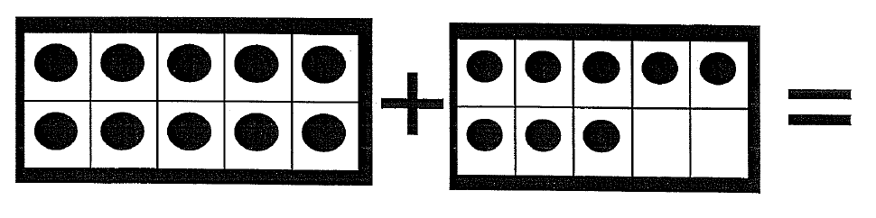18

